USER REQUEST PORTAL
@CREATIVITY THINK (9483175986/7019689991)

ABSTRACT:
User Request Portal is a web-based application designed to manage, track, and approve user requests efficiently. The system allows users to create new requests, monitor status updates, and access analytical dashboards. Administrators can review, approve, and track requests while generating detailed reports and insights on portal usage. Built with Django and Django Rest Framework for backend operations and React with redux and axios for frontend interactions, the platform ensures structured workflows, real-time updates, and a seamless communication channel between users and administrators..

INTRODUCTION OF THE PROJECT:
Organizations and service providers often struggle to manage incoming requests due to unorganized communication channels, lack of centralized tracking, and delayed approvals. User Request Portal addresses these challenges by providing a centralized web interface for submitting, monitoring, and approving requests. Users can create requests, track their status, and access dashboard analytics. Administrators can efficiently manage requests, generate insights, and improve responsiveness. This portal enhances transparency, accountability, and operational efficiency for both users and administrators..

PROJECT OBJECTIVES:

• Provide a centralized platform for submitting and managing requests
• Allow users to track request status in real time
• Enable administrators to approve, reject, or manage requests efficiently
• Offer dashboards for analytical insights and reporting
• Maintain a record of all requests and status updates
• Reduce response time and streamline workflows
• Support scalable backend APIs for multiple request types
• Facilitate transparency and accountability in service operations

PROBLEM OF THE STATEMENT:
Manual or unstructured request handling creates delays, miscommunication, and lack of accountability. Users often cannot track the status of their requests, while administrators struggle to generate meaningful insights or prioritize actions. The User Request Portal resolves these issues by offering a structured system with real-time status tracking, admin approval workflows, and dashboard analytics, improving both user satisfaction and operational management..

MOTIVATION OF THE PROJECT:
• To digitalize request submission and tracking
• To provide users with real-time status updates
• To streamline administrative approvals and monitoring
• To maintain accurate logs for transparency and reporting
• To support data-driven decision-making through dashboards
• To improve operational efficiency and response times
• To offer a user-friendly interface for both end-users and admins

BLOCK DAIGRAM OF PROJECT:

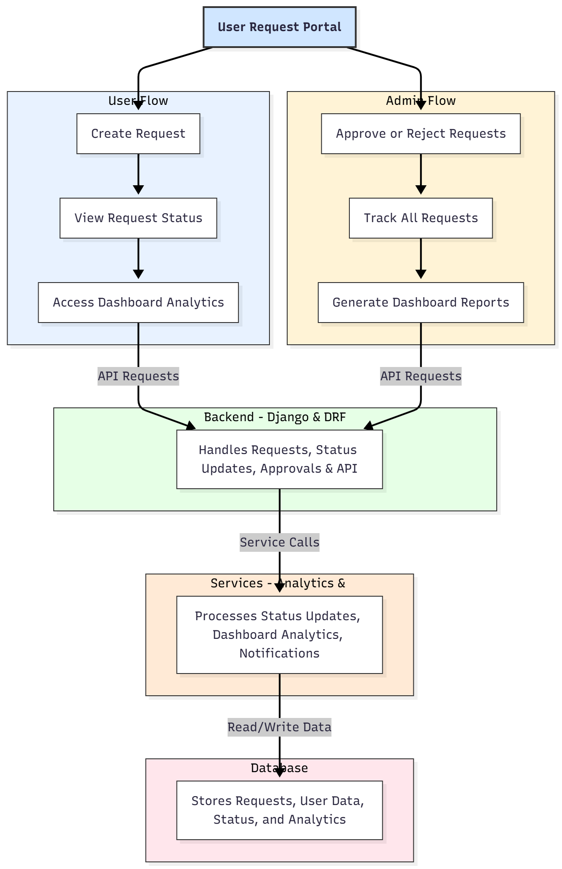

WORKING OF THE PROJECT:
Users begin by creating a new request through the portal. The backend validates the request and stores it in the database with an initial status. Users can monitor the request status in real time through their dashboard. Administrators access pending requests, approve or reject them, and update the status accordingly. All actions are logged automatically, while the analytics module generates visual reports and usage statistics. Notifications may be sent to users for updates. This workflow ensures efficient request handling, transparency, and real-time tracking for both users and administrators..

SOFTWARE REQUIREMENT:
- Backend:
  - Python 3.x
  - Django
  - Django REST Framework
  - SQLite/PostgreSQL
- Frontend:
  - Node.js and npm
  - React.js
  - Axios
- Development Tools:
  - Visual Studio Code
  - Postman (for testing APIs)
  - Git/GitHub (for version control)
- Server/Deployment (Optional):
  - Gunicorn, Nginx, or Heroku/AWS for hosting

ADVANTAGES OF THE PROJECT:

• Centralized and efficient request management
• Real-time status tracking for users
• Streamlined administrative approvals
• Dashboard analytics for insights and reporting
• Reduced response time and manual errors
• Accurate and transparent record keeping
• User-friendly interface for seamless operations
• Scalable for multiple service areas

APPLICATIONS OF THE PROJECT:
• Customer support and service portals
• Residential query management
• IT helpdesk or kiosk systems
• Internal departmental request tracking
• Complaint or issue management systems
• Any service-based organization needing request approval workflows

REFERENCES:

- Django REST Framework Documentation — Django Software Foundation. Django Documentation. Available: https://docs.djangoproject.com/
- Django REST Framework. DRF Documentation. Available: https://www.django-rest-framework.org/
- React. React Official Documentation. Available: https://reactjs.org/docs/getting-started.html
- Redux. Redux Documentation. Available: https://redux.js.org/introduction/getting-started
- PostgreSQL Global Development Group. PostgreSQL Documentation. Available: https://www.postgresql.org/docs/
- MySQL. MySQL Reference Manual. Available: https://dev.mysql.com/doc/
- Git. Git Documentation. Available: https://git-scm.com/doc
- Node.js. Node.js Documentation. Available: https://nodejs.org/en/docs/
- Axios. Axios Documentation. Available: https://axios-http.com/docs/intro
- Socket.io Documentation – https://socket.io/docs/

